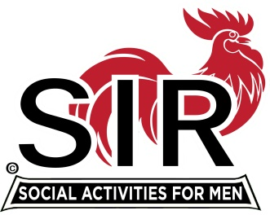
Las Trampas Branch 116
BEC Meeting Agenda
December 21, 2020, 8:00 AM
The Mission of SIR is to enhance the lives of our members through fun activities, events and luncheons – while making friends for life.

8:00 Coffee Available !!!

- Call to order; Secretary confirm a quorum
- Secretary – Fred Schafer – Approval of November minutes
- Treasurer – Alan Fitzgerald: Birthday Boys/Budget 2020
- Membership: Phil Goff
- Activities report: Fred Wachowicz
Bernie Wrobleski (Golf)
5) Big SIR report – Michael
- “Transition of Power”!!!!!!!!!!!!!
- Little SIR report
- Diversity Committee update
- Birthday Boys

- AOB

- Date for next meeting?

